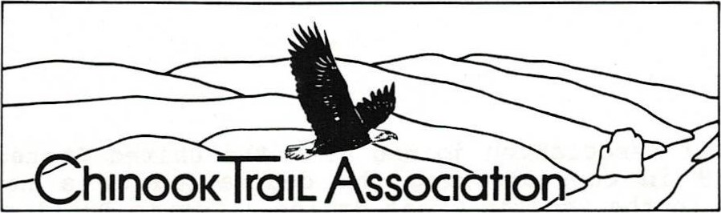
Autumn 1990
Dear Friends,
Our brochure may look familiar. We have mailed lots of them. You may have received one. You may have been given one by a friend, or picked up a copy at Recreational Equipment, Inc. REI is one of our earliest boosters.
You may have responded by becoming charter members in the Chinook Trail Association, and we welcome you to our ranks. Some of you, however, may have decided to wait and see what happens before making a commitment. We are pleased now to give you a brief update on developments over the last few months. But first, let's answer the question of who are "we"?
"We" are Don Cannard and Ed Robertson, long—time fr lends and retired Vancouver elementary school principals. We've hiked countless miles together over the years, and we 're committed to the idea that trails are an important part of America's heritage. Prom the time of our country's birth, America has depended on trails. Preceding the colonists were Native Americans whose trails still exist in many places. The Chinook Trail will, in many instances, follow the foot paths of those who were here thousands of years ago.
Nowadays we rely on our marvelous surface and air transportation systems, but we are also seeking out trails for relaxation and enjoyment of nature. It seems that more folks than ever before are out there on the urban, rural and back country trail systems. The Chinook Trail will add significantly to our trail opportunities.
We got the idea for a Chinook Trail back in 1986 while on the summit of Silver Star, a 4000—foot peak noted for its glorious wildflower displays. We thought how wonderful it would be to have a 200—mi1e recreational trail encircling the Columbia River Gorge.
The Winter of 1988, we brought some interested outdoor folks together and incorporated the Chinook Trail Association to promote the concept and gather support from city, county, state and federal governments, private property owners, and the trail—using public.
The past couple of years have been busy. We've travel led many miles in and around the Gorge, participating in meetings and speaking on behalf of the Chinook Trail . City, county, state and federal recreation planners have greeted the idea with enthusiasm. The Association is being supported by four corporations, two foundations, and we are optimistic for more such support as the proposal gains momentum.(over)
Chinook Trail Association
PO. Box 997, Vancouver. WA 98666-0997

The Chinook Trail Association joined with the United States Forest Service in June of 1989 in co—sponsoring the dedication of a new trailhead and connecting link to the Pacific Crest National Scenic Trail where the Mexico— to—Canada Crest trail enters Washington near Bonneville Dam.
The Chinook Trail Association letterhead and logotype depicts an eagle soaring over the Columbia River Gorge. But why an eagle? The great bird is not uncommon in the Gorge, and figures prominently in the culture of Native Americans we are honoring in naming the trail. Over the course of time, the eagle became not only our national symbol, but also an inspiration for those who would attempt the difficult or chal lenging.
We have engaged in a number of successful trail building work parties in Clark County. If you would like to join with us in these or contribute your services in other ways please indicate below.
The Chinook Trail Association invites you to join in our chal lenge of completing the Chinook Trail. It may take the rest of this century, but it will be done with the help of you who share our commitment to trails and their link with our country's past.
Sincerely ,
Don Cannard Ed Robertson
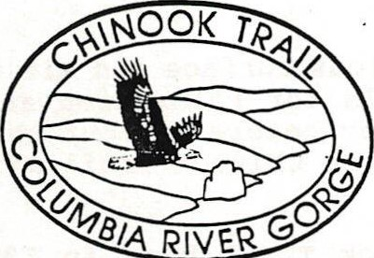
I wish to order the multicolored embroidered patch of the Chinook
Trail Association. Enclosed is $3.50 to cover the cost of the patch ($3.00)
I wish to become a volunteer:
Trail building | Assist with mailings
Membership | Promotions (photography ,
Other | writing, newsletters)
Name :

Address :
City/ State Zip: Phone No:
Return to: Chinook Trail Association
P. O. Box 997
Vancouver, WA 98666-0997

